To build decentralized applications (dApps) with Angular, you can leverage the capabilities of the Ethereum blockchain and smart contracts. Here's a step-by-step guide to getting started:

**Step 1: Set Up Your Development Environment**

Install Node.js: Visit the official Node.js website (https://nodejs.org) and download the appropriate version for your operating system.

Install Angular CLI: Open a terminal or command prompt and run the following command to install Angular CLI globally:

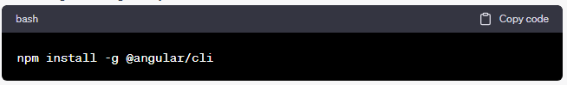

(npm install -g @angular/cli)

**Step 2: Create a New Angular Project**

Open a terminal or command prompt and navigate to the directory where you want to create your project.

Run the following command to create a new Angular project: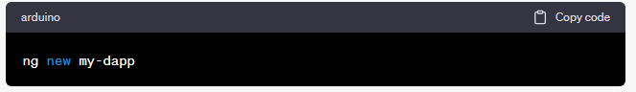

(ng new my-dapp)

Change to the project directory: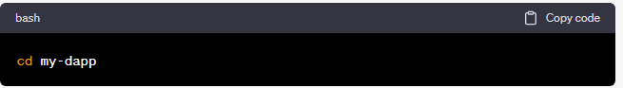

(cd my-dapp)

**Step 3: Install Web3.js Library**

Web3.js is a JavaScript library for interacting with Ethereum.

Run the following command to install Web3.js as a dependency for your project:

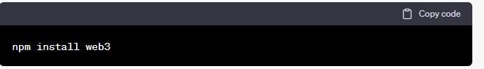

**(npm install web3)**

**Step 4: Develop Your dApp**

Open your favorite code editor and navigate to the project directory.

Explore the ‘src’ folder to modify the default Angular components (‘app.component.ts’, ‘app.component.html’, etc.) or create new components as needed.

Use the Web3.js library to interact with the Ethereum blockchain, such as connecting to a provider, deploying smart contracts, and interacting with contract functions.

Import the Web3.js library into your Angular component by adding the following line at the beginning of the file:

(import Web3 from 'web3';)

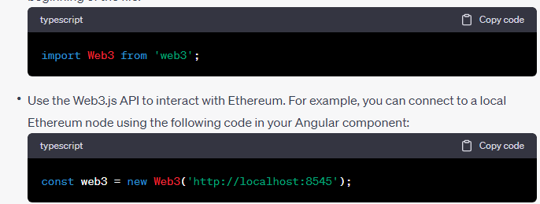

(const web3 = new Web3('http://localhost:8545');)

* Replace **'http://localhost:8545'** with the URL of your Ethereum node.

Step 5: Build and Run Your dApp

In the terminal or command prompt, ensure you are in the root directory of your Angular project (**my-dapp**)

Run the following command to build your Angular app:

(ng build)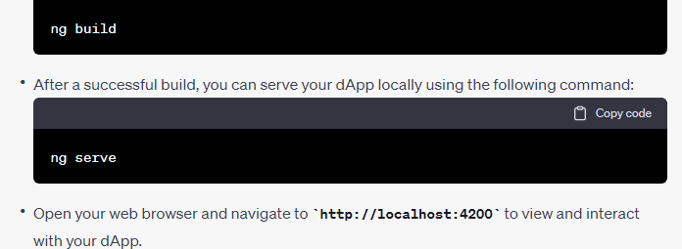( ng serve)

Open your web browser and navigate to **http://localhost:4200** to view and interact with your dApp.